Working with SQL – Assignment

Consider the following Set of Tables:
Data for SalesPeople table:

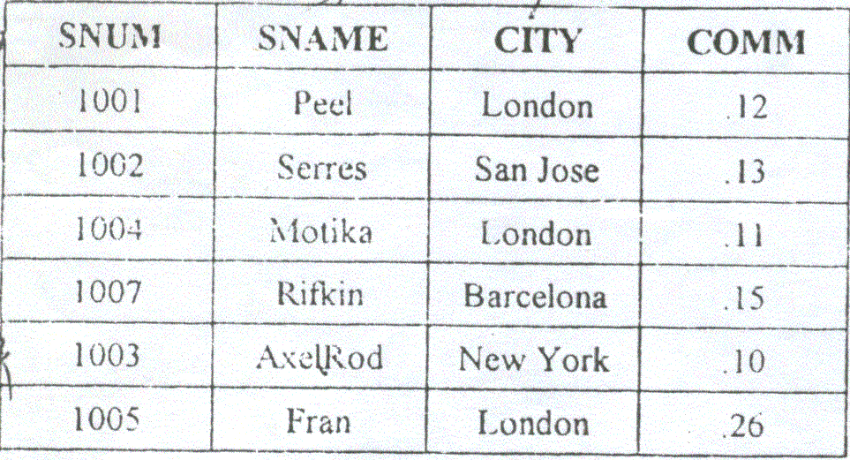

Data for Customers table:

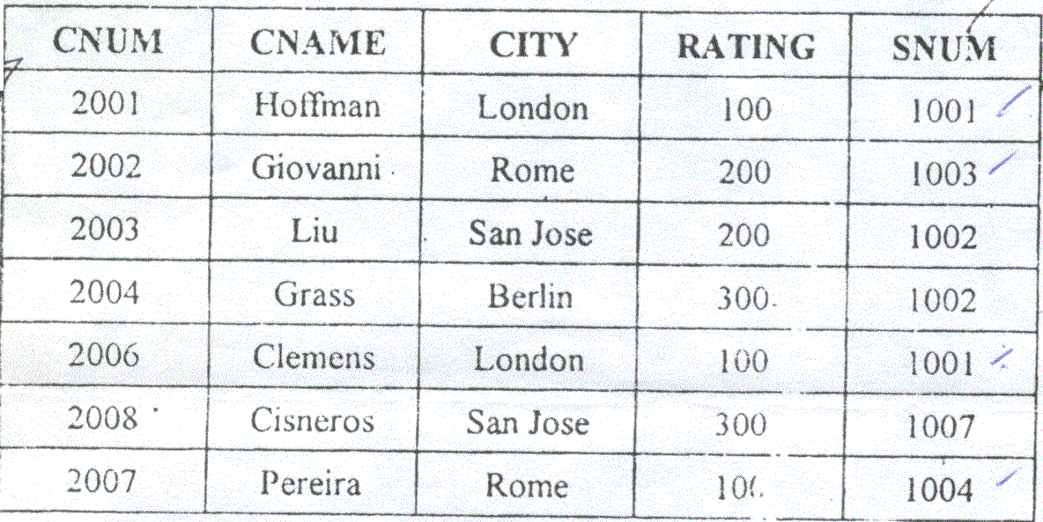

Data for Orders Table:

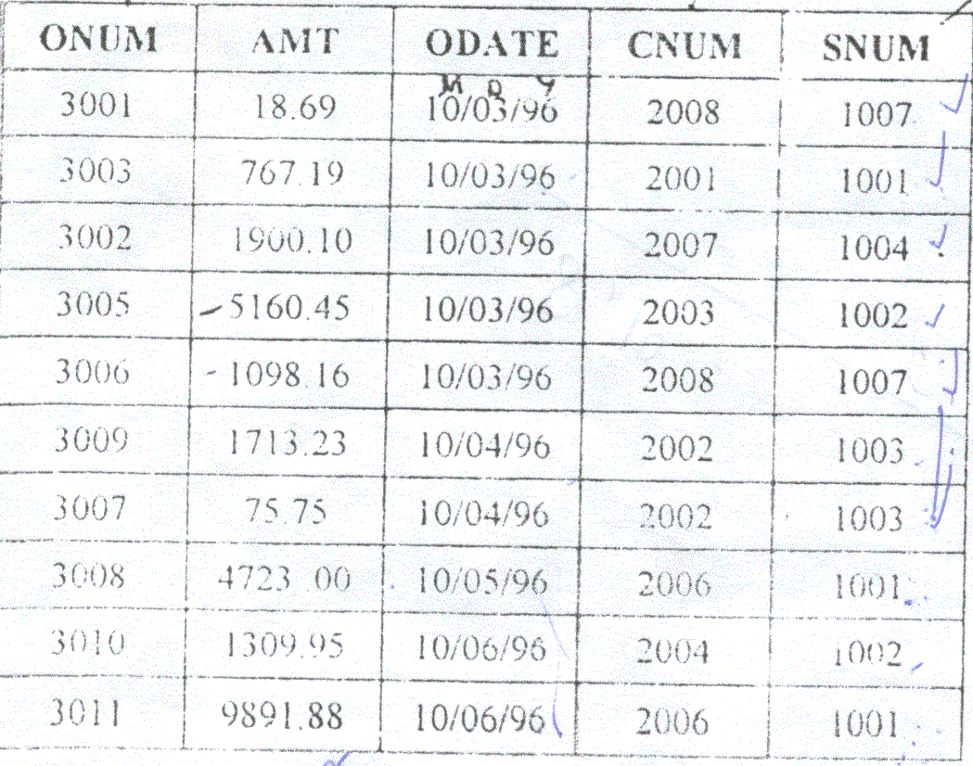
Execute the Script CreateTable.sql for the tables.
- List all the columns of the SalesPeople table
- List all customers with a rating of 100.
- Find all records in the Customers table with NULL values in the city column
- Find the largest order taken by each salesperson on each date
- Arrange the Orders table by descending customer number.
- Find which salespeople currently have orders in the Orders table.
- List names of all customers matched with the salespeople serving them.
- Find the names and numbers of all salespeople who had more than one customer.
- Count the orders of each of the salespeople and output the results in descending order.
- List the Customer table if and only if one or more customers in the Customer table are located in San Jose.
- Match salespeople to customers according to what city they lived in.
- Find the largest order taken by each salesperson.
- Find customers in San Jose who have a rating above 200.
- List the names and commissions of all salespeople in London.
- List all the orders of salesperson Motika from the Orders table.
- Find all customers with orders on October 3.
- Give the sums of the amounts from the Orders table, grouped by date, eliminating all those dates where the SUM was not at least 2000.00 above the MAX amount.
- Select all orders that had amounts greater than at least one of the orders from October 6.
- Write a query that uses the Exists operator to extract all salespeople who have customers with a rating of 300.
- Find all the customers having same ratings
- Find all customers whose CNUM is 1000 above the SNUM of Serres.
- Give the salespeople’s commissions as percentage instead of decimal numbers.
- Find the largest order taken by each salesperson on each date, eliminating those MAX orders which are less than $3000.00 in value.
- List the largest orders for October 3, for each salesperson.
- Find all customers located in cities where Serres has customers.
- Select all customers with rating above 200.00.
- Count the number of salespeople currently listing orders in the Orders table.
- Write a query that produces all customers serviced by salespeople with a commission above 12%. Output the customer’s name and the salesperson’s rate of commission.
- Find salespeople who have multiple customers.
- Find salespeople with customers located in their city.
- Find all salespeople whose name starts with ‘P’ and the fourth character is ‘I’.
- Write a query that uses a subquery to obtain all orders for the customers named Cisneros. Assume you do not know his customer number.
- Find the largest order for Serres and Rifkin.
- Extract the salespeople table in the following order : SNUM,SNAME, COMMISSION,CITY.
- Select all customers whose names fall in between ‘A’ and ‘G’ alphabetical range.
- Select all the possible combinations of customers that you can assign.
- Select all the orders that are greater than the average for October 4.
- Write a select command using a correlated subquery that selects the names and numbers of all customers with ratings equal to the maximum for their city.
- Write a query that totals the orders for each day and places the results in descending order.
- Write a query that produces the rating followed by the name of each customer in San Jose.
- Find all orders with amounts smaller than any amount for a customer in San Jose.
- Find all orders with above average amounts for their customers.
- Write a query that calculates the amount of the salesperson’s commission on each order bya customer with rating 100.0
- Write a query that selects the highest rating in each city.
- Count the customers with ratings above San Jose’s average.
- Write a query that produces all parts of salespeople with themselves as well as duplicate rows with the order reversed.
- Find all salespeople that are located in either Barcelona or London.
- Find all salespeople with only one customer.
- Write a query that joins the customer table to itself to find all pairs of customers served by a single salesperson.
- Write a query that will give you all orders for more than $1000.00.
- Write a query that lists each order number followed by the name of the customer who made that order.
- Find the average commission for salespeople in London.
- Find all orders credited to the same salesperson who has given service to
Hoffman (CNUM 2001)
- Find all salespeople whose commission is between 10 and 12 (both inclusive)
- Write a query that selects each customer’s smallest order.
- Write a query that counts the number of non-Null city values in the customer table.
- Find all customers who are not located in San Jose and whose rating is above 200.
- Which salespersons attend to customers not in the city that have been assigned to them
- Which salespeople get commission greater than 11 and are serving customers rated less than 250.
- Write a query to get the details of the customer who has given the maximum number of orders.
- On which days has Hoffman placed orders.
- How many salespersons have succeeded in getting orders.
- How many customers have placed orders.
- On which date has each salesperson booked an order of maximum value.
- Who is the most successful salesperson.
- Who is the worst customer with respect to the company.
- Find all orders greater than the average for October 4th.
- Which customers have above average orders.
- List all customers with ratings above San Jose’s average.
- Select the total amount in orders for each salesperson for whom the total is greater than the amount of the largest order in the table.
- Give names and numbers of all salespersons who have more than one customer.
- Select all salespersons by name and number who have customers in their city whom they don’t service.
- Which salesperson(s) should be fired.
- Calculate the commission for each salesman.
- Write a query using an ANY or ALL that will find all sales people who have no customers located in their city.

